Project Planning Phase
Project Plan — Script-Controlled ACL (Backlog, Sprints, Estimation)

Date | 3 October 2026
Team ID | TBD
Project Name | Script-Controlled ACL — Branch-Based Record Access
Maximum Marks | 5 Marks

Product Backlog, Sprint Schedule, and Estimation (4 Marks)
Proposed backlog for the three-hour ServiceNow lab. Estimate scale follows the supplied planning guide (1, 2, 3, 5); points, priorities, and sprint assignment are planning estimates, not measured delivery data.
Sprint | Functional Requirement (Epic) | User Story Number | User Story / Task | Story Points | Priority | Team Members
Sprint-1 | Environment & data | USN-1 | As an administrator, I can create the EEE test user and roles bb1–bb4 so ACL checks use repeatable identities. | 1 | High | TBD
Sprint-1 | Environment & data | USN-2 | As an administrator, I can create u_institution_details with the required fields, ECE/EEE/CSE choices, and branch seed records so access can be tested. | 3 | High | TBD
Sprint-1 | READ restriction | USN-3 | As an administrator, I can configure the active advanced READ ACL with required role bb1, Branch = EEE data condition, and the admin exception so reads follow the lab rules. | 3 | High | TBD
Sprint-1 | READ restriction | USN-4 | As a tester, I can verify bb1 sees only EEE records, a user without bb1 sees none, and admin sees all branches so READ outcomes are confirmed. | 2 | High | TBD
Sprint-2 | Operation ACLs | USN-5 | As an administrator, I can configure separate CREATE (bb2), WRITE (bb3), and DELETE (bb4) ACLs without data conditions so each operation has its specified role gate. | 5 | High | TBD
Sprint-2 | Operation ACLs | USN-6 | As a tester, I can verify positive and negative create, edit, and delete role combinations and record actual admin behavior so CRUD controls are checked. | 3 | High | TBD
Sprint-2 | Validation & close-out | USN-7 | As a tester, I can verify lists/forms and Service Portal where enabled so all used interfaces respect the record ACLs. | 2 | Medium | TBD
Sprint-2 | Validation & close-out | USN-8 | As the project team, I can capture evidence and document scope, test identities, and unresolved assumptions so results are traceable. | 1 | Medium | TBD

Project Tracker, Velocity & Burndown Chart: (4 Marks)
Sprint | Total Story Points | Duration | Sprint Start Date | Sprint End Date (Planned) | Story Points Completed (at planned end) | Sprint Release Date (Actual)
Sprint-1 | 9 | 6 workdays  (proposed) | TBD | TBD | Pending — not started | Pending
Sprint-2 | 11 | 6 workdays  (proposed) | TBD | TBD | Pending — not started | Pending

Velocity and planned workload:
Total proposed backlog = 20 points (9 + 11). Planned workload average = 20 points ÷ 2 planned sprints = 10 points per sprint. This is a forecast, not measured team velocity. The separate example in the supplied Planning Logic guide reports 16 points per sprint for a different sample; it is not used as this project’s capacity.
Actual velocity = accepted story points completed ÷ completed sprints. No sprint has been completed yet, so actual velocity is TBD. With the proposed six-working-day duration, the planned average rate is 10 ÷ 6 = 1.67 points per working day.
Planning basis: supplied ACL lab brief and Planning Logic guide. Burndown method reference: https://www.atlassian.com/agile/tutorials/burndown-charts

Burndown Chart — Ideal Baseline (Proposed)
The lines show an even-work forecast for the proposed six-working-day sprints. They are not actual burn data; update the chart from remaining accepted work each day after the sprint begins.
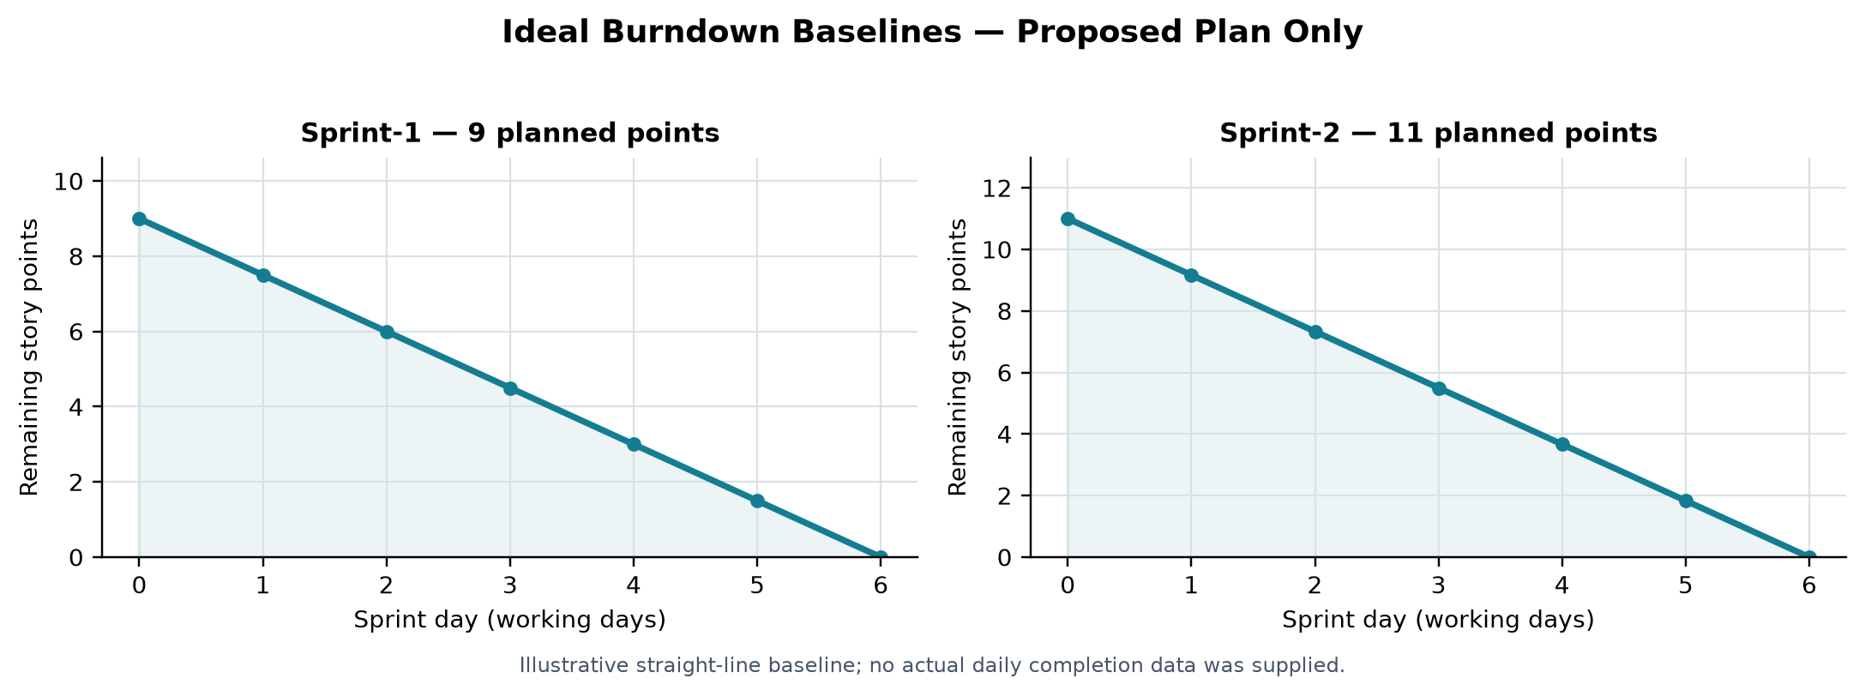
Planning assumptions and verification notes: Sprint duration is proposed as six working days, matching the template example; calendar dates and team assignments were not provided. The lab assigns bb1–bb4 to one EEE user, so use distinct test identities or vary assignments to isolate permissions. READ explicitly grants admin access; verify admin behavior for CREATE/WRITE/DELETE in the instance. Those three ACLs have no data conditions in the source.

